**Django Views**

**------------------**

1. **Create an API for updating records,using PUT and PATCH.**

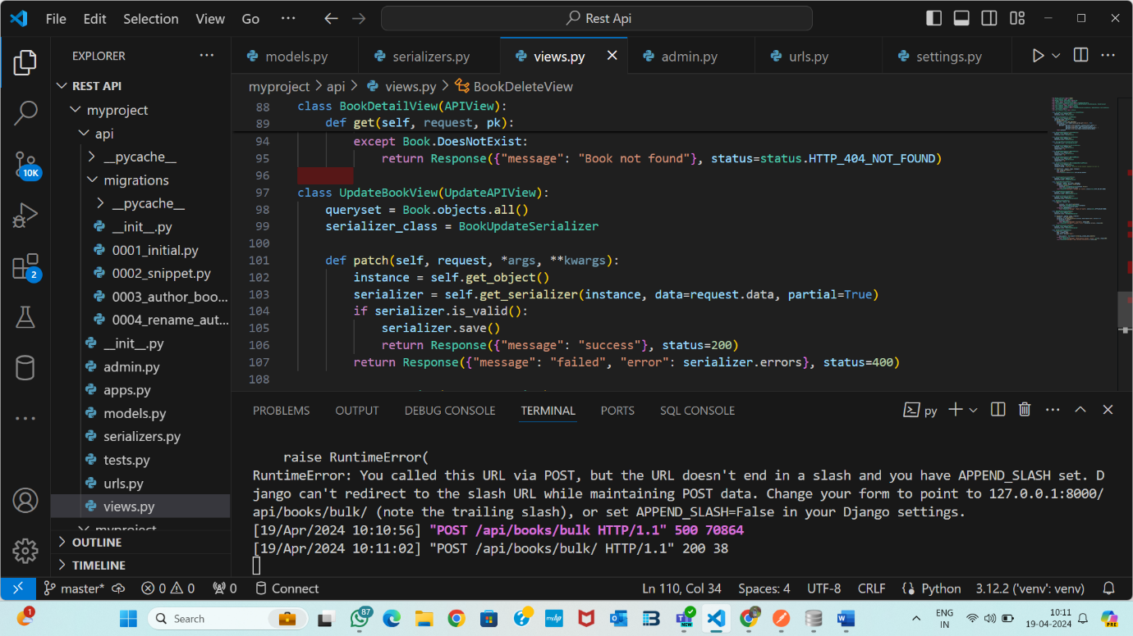

**PUT**

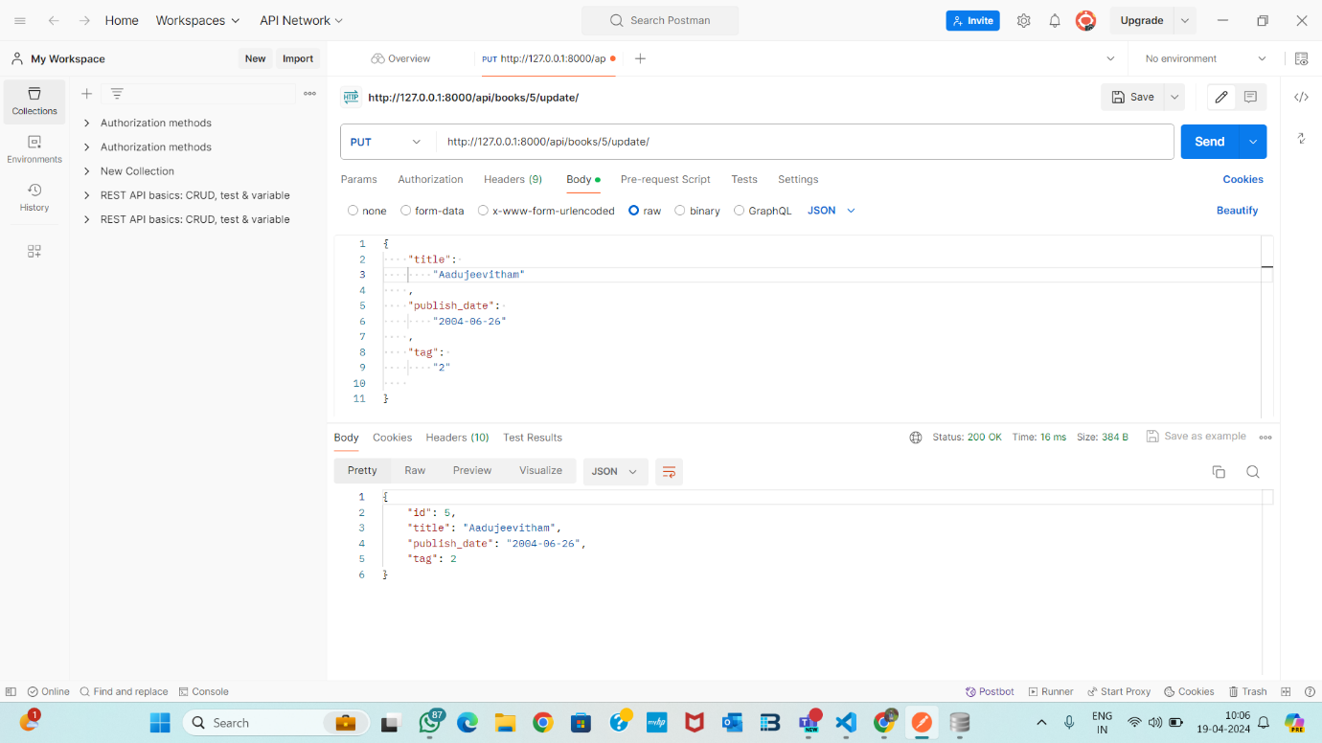

**PATCH**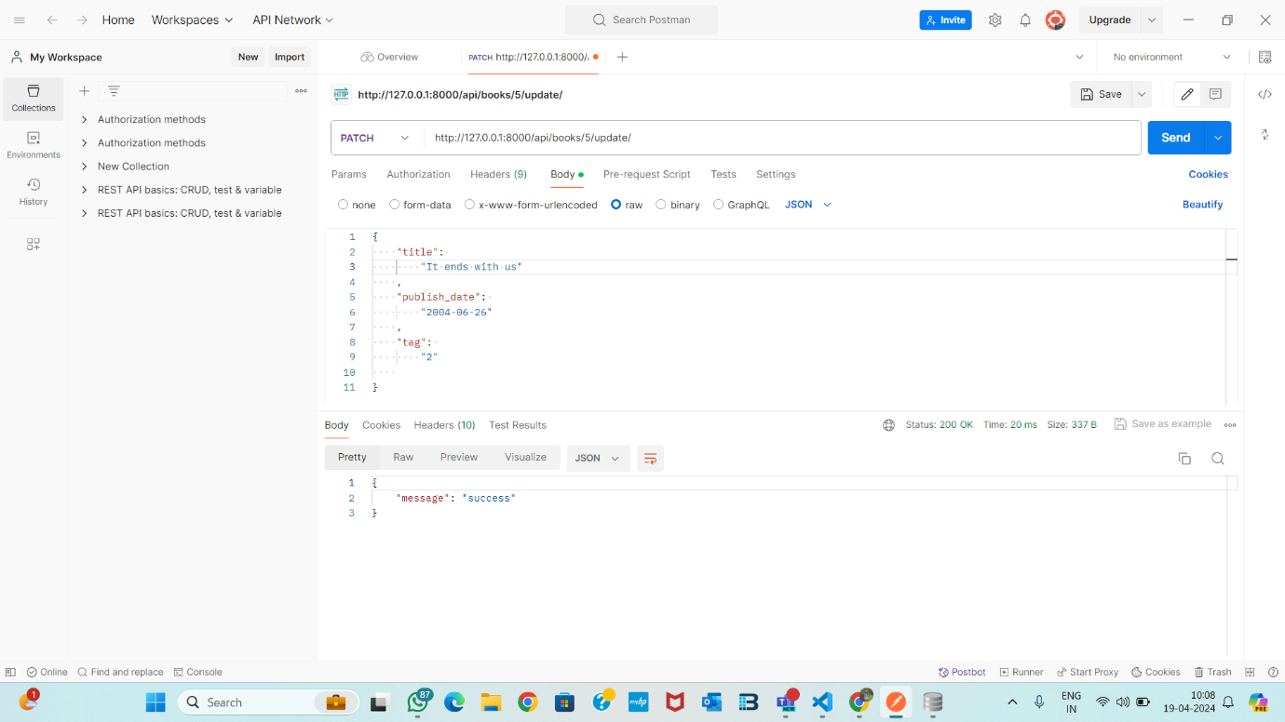

1. **Create an API for deleting records with custom error messages.**

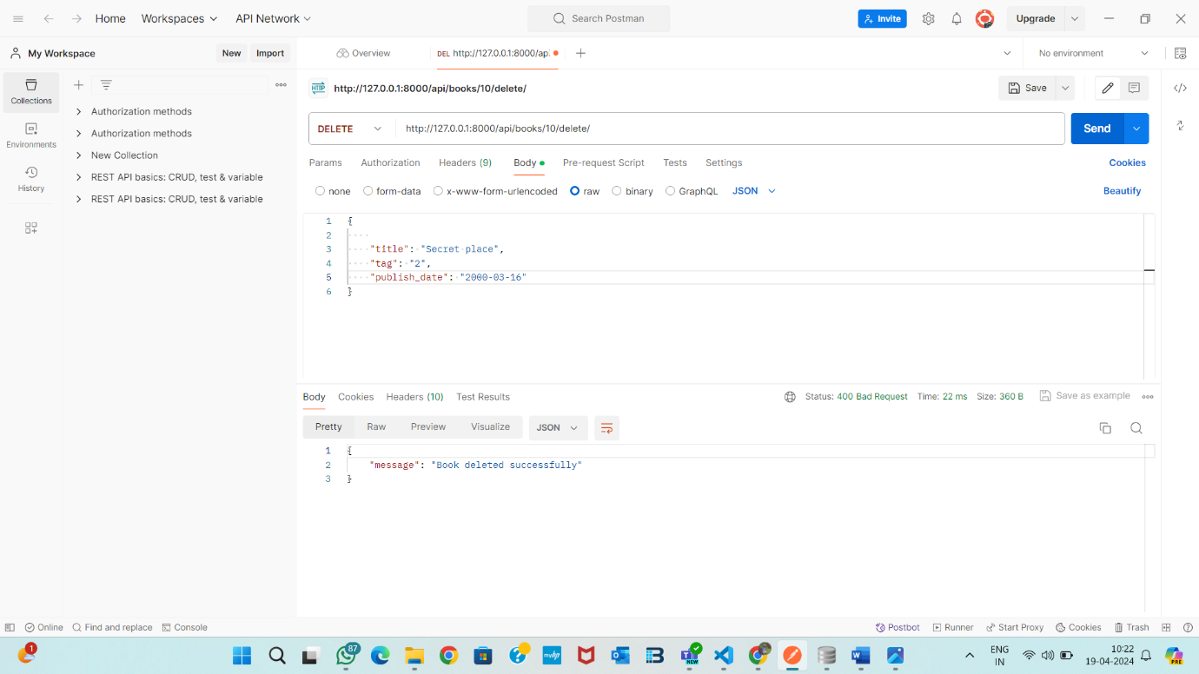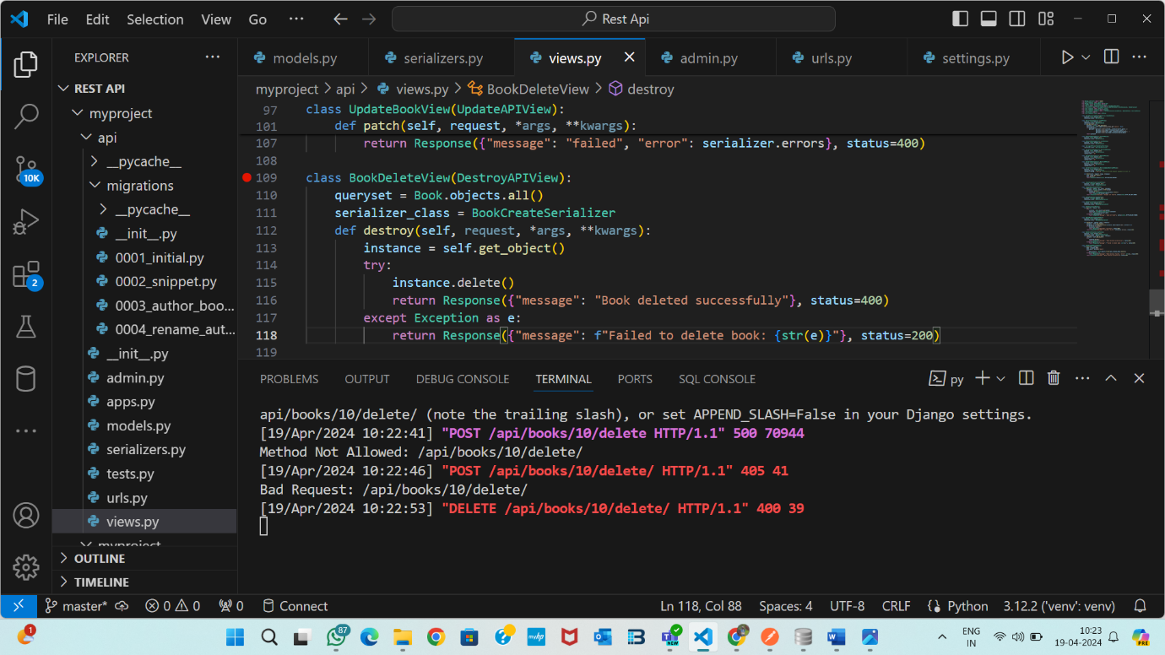

**3. Create an API for bulk deletion**

